**HEALTH GENIE**

A Unique Health Care Chatbot entailing the power of ChatGPT 4

**A PROJECT REPORT**

***Submitted by***

**SHRISHTY ( 20BCS6784 )**

***in partial fulfillment for the award of the degree of***

**BATCHELORS OF ENGINEERING**

**IN**

**COMPUTER SCIENCE ENGINEERING**



**Chandigarh University**

MAY 2023



**BONAFIDE CERTIFICATE**

Certified that this project report on “ **HEALTHCARE CHATBOT APPLICATION** ” is the Bona fide work of “**SHRISHTY GUPTA (20BCS6784)** ” who carried out the project work under my/our supervision.

**SIGNATURE SIGNATURE**

Mr. Aman Kaushik

Dr. Alankrita Aggarwal

Associate Professor

**HEAD OF THE DEPARTMENT SUPERVISOR**

( CSE- AIML ) (AIML)

Submitted for the project viva-voce examination held on_____________________

**INTERNAL EXAMINER EXTERNAL EXAMINER**

**ACKNOWLEDGEMENT**

I express my sincere regard and gratitude to my project guide Dr.Alankrita Aggarwal, Supervisor, Department of APEX INSTITUTE OF TECHNOLOGY, Chandigarh University, Punjab for her valuable time, guidance, encouragement, support and cooperation throughout the duration of my project.

I would sincerely like to thank my Department for giving me the opportunity to work on this amazing project on A health care chatbot which helped me in enhancing my technical skills. This project helped me in understanding the various parameters which are involved in the development of a chatbot including the basics of Node.JS and the working and integration of APIs with the back end to create a fully functional Chatbot.

I would like to express my deepest appreciation for having such encouraging mentors and to all of my friends who always advised and motivated me throughout the course.

**Table Of Contents**

**ACKNOWLEDGEMENT…………………………………………………………… 3**

**ABSTRACT……………………………………………………………………………4**

**Chapter 1 (INTRODUCTION)…………………………………………………… 7-14**

* 1. **Introduction……………………………………………………… 7**
  2. **Project Identification………………………………………………..**
  3. **Timeline of the Project……………………………………………. 13-14**

**Chapter 2 (LITERATURE SURVEY)……………………………… 15-24**

* 1. **What is objective of HealthGenie? …………. 15**
  2. **What is the Importance? .................... 16**
  3. **Features/Characteristic used……………………………………….. 16-18**
  4. **Goals of the project…………………………… 19-20**

**Chapter 3 (DESIGN FLOW / PROCESS )…………………..………… 25-42**

* 1. **Software development life cycle ……………………………… 25**
     1. **Waterfall Model………………………………. 25-26**
     2. **Diagram……………………………………….. 27**
  2. **Technologies Used ………………………………………….. 28-31**
     1. **JS……………………………………. 28-29**
     2. **WhatsApp API**
  3. **Constraint Identification …………………………………… 38- 43** 
     1. **Generate multiple design alternates…………... 38**
     2. **Methods of ideation**
  4. **Selection of best design and implementation plan …………………. 41-43**

**Chapter 4 RESULT ANALYSIS AND VALIDATION…… ……….. 44-49**

* 1. **Important code and Website snippets ……………………………. 44-46**
     1. **VS Code Index**
     2. **JS files**
     3. **Website Preview**
  2. **System Testing and Implementation ………………………………… 47**
     1. **Description of test case**
     2. **Types of Testing**
     3. **System testing**
  3. **Software verification and validation………………………….. 48**

**Chapter 5 (CONCLUSION AND FUTURE WORK)…….................. 50-52**

* 1. **Conclusion ……………………………………………………. 50**
  2. **Future Work………………………………………………….. 51-52**

**ABSTRACT**

The use of chatbots is growing across various industries, including healthcare, the service sector, and more lately, education. Because of their portability and affordances, chatbots are becoming increasingly popular particularly in the field of healthcare.

The healthcare sector is very large. Patients see doctors for a variety of reasons, from seeking guidance on prescriptions to attending to urgent medical conditions. Healthcare chatbots are computer programs designed to simulate human conversation to assist users in managing their health and well-being. These chatbots leverage natural language processing (NLP) and artificial intelligence (AI) technologies to interpret user requests and provide relevant information and recommendations.

My ChatBot “HealthGenie” harness the power of ChatGPT which helps this virtual assistant to effectively understand and respond to a wide array of patient inquiries, provide personalized health information, and offer guidance on various medical topics.

**CHAPTER: 1**

**INTRODUCTION**

* 1. **INTRODUCTION**

AI systems have the capacity to mimic human cognitive processes and improve decision-making. They are specifically created to offer a real-time interaction with the end-user. It is only a computer software that uses text messages to interact with users on a website or application.

A chatbot is a software that mimics human-to-computer communication through the use of natural language. Chatbots converse with customers in an interaction that uses human input and provide helpful assistance. The user is led to believe that it is conversing with a person even though they are conversing with a computer

Even though a phone call or email might be considered as easy forms of communication with the professionals , they are not always the most effective.

Medical chatbots can answer inquiries regarding prescriptions, appointment scheduling, and other issues. As a result, medical professionals and facilities may relax knowing that questions from patients will be promptly addressed.

Users can also choose from options like scheduling, reminders, and educational content.

Chatbots may help save healthcare companies money, which they can utilise for other investments or to get out of a difficult circumstance. By moving to a chatbot, a healthcare company can save money on customer support staff and their training.

Overall, healthcare chatbots have the potential to revolutionize the healthcare industry by providing convenient and personalized care to patients, but careful consideration must be given to their development and implementation to ensure their safety and efficacy.

**1.2 PROJECT IDENTIFICATION**

Project identification for a ChatGPT-powered healthcare chatbot entails identifying the demand for an intelligent conversational agent in the industry.

The goal is to create a chatbot that can give consumers looking for advice about healthcare personalised, correct, and easily accessible information. The chatbot can engage in natural language conversations, comprehend user inquiries, and provide pertinent responses by utilising ChatGPT's capabilities.

The project intends to address the rising need for immediate medical assistance, lighten the load on medical staff, increase patient education, and boost healthcare outcomes generally.

The purpose of ‘HealthGenie’ a healthcare chatbot is to provide an AI assistant which would harness the power of ChatGPT and can effectively understand and respond to a wide array of patient inquiries, provide personalized health information, and offer guidance on various medical topics. The power of ChatGPT lies in its ability to comprehend context, interpret user intent, and generate relevant and coherent responses.

ChatGPT can assist users in triaging their symptoms, providing initial recommendations for self-care or determining the urgency of seeking medical attention. Its vast knowledge base allows it to offer reliable information on medications, treatments, and health conditions, empowering users to make informed decisions about their healthcare.

My chatbot would provide personalized health guidance as to what medication should be taken for user symptoms and tells if the condition needs professional guidance.

**1.3 TIMELINE OF THE PROJECT**

***Week 1***

Research and planning of project and submitting project proposal.

***Week 2-4***

Start working on the project and give 2nd project report. Learnt the basics of web development like Javascript.

***Week 5-7***

Review the work done and test the progress as scheduled. Learnt in depth about JS, Integration of APIs and researched about ChatGPT.

***Week 8-10***

Bug fixes and changes in the project if required and made presentation of final project and report.

**Total weeks: 10**

**CHAPTER: 2**

**LITERATURE SURVEY**

## **2.1 What is the objective of Health Care Chatbot?**

Depending on the particular requirements and aims of the healthcare organization or application, the objectives of a chatbot for healthcare can change. However, the following are some typical objectives for healthcare chatbots:

* Provide 24/7 Access to Healthcare Information: Giving users continuous access to reliable and current healthcare information is one of the main goals of a healthcare chatbot. Users can ask inquiries about signs, conditions, treatments, and general health advice, and they will promptly and accurately receive answers.
* Assist in Symptom Triage and Self-Care: Users can analyze their symptoms and receive early advice on self-care practices from healthcare chatbots. Chatbots can make suggestions for treating mild illnesses or identify the need for more extensive medical care by posing pertinent questions and examining user responses.
* Personalize Health Recommendations: Delivering personalized health advice based on user profiles, medical histories, and preferences is one of the main goals of healthcare chatbots. Chatbots can offer individualized guidance on food, exercise, preventive care, and disease management by analyzing user data and utilizing machine learning algorithms.
* Improve Patient Engagement and Education: Healthcare chatbots provide instructional information, advice on healthy living, and motivational assistance in an effort to actively involve users in managing their health. They can motivate consumers to lead healthier lifestyles, follow prescribed treatments, and take an active role in their healthcare.
* Enhance Access to Mental Health Support: Healthcare chatbots' assistance for mental health is a key goal. They can give users a private forum to talk about their mental health, offer coping mechanisms, and, if necessary, direct users to the proper mental health resources or professionals.
* Complement and Support Healthcare Providers: Healthcare chatbots are created to supplement the job of healthcare providers by providing consumers with help and information while lightening the workload on healthcare workers. They can help with patient triage, provide fundamental medical knowledge, and guarantee that consumers get quick and accurate advice.

**Healthcare chatbots can improve patient engagement, improve health outcomes, and boost healthcare delivery efficiency by being in line with these goals.**

**2.2 Why is Health Care Chat Bots Important?**

There are several reasons why my health care chatbot is important, including:-

1. The main focus of my chatbot is to provide Personalized and Tailored Care. By using the power of ChatGPT it effectively understand and respond to a wide array of patient inquiries.

1. It can provide immediate support, cutting down on the amount of time it takes for a user to receive the information or direction they need.
2. Healthcare chatbots offer support and information that is available around-the-clock. Users don't need to make appointments in person or wait in queue to use the chatbot; they may access it anytime, from anywhere.
3. Chatbots for healthcare can gather useful user information, such as symptoms, demographics, and preferences. To find trends, comprehend typical health issues, and enhance healthcare services, this data can be analysed.
4. By maximising resources and streamlining procedures, healthcare chatbots have the potential to save money on medical care. Chatbots can assist users in managing mild illnesses without the need for pointless doctor appointments or emergency department trips by offering preliminary diagnoses and self-care recommendations.

**2.3 Feature/Characteristic Used**

* Pure backend project running with the help of Javascript.
* Whatsapp.JS API is used to integrate WhatsApp with my chatbot.
* No need for a front end since I used the chatbot for whatsapp interface.
* OpenAI API is used to integrate ChatGPT with my project.
* Node.JS is used in backend.

## **2.4 What are the goals of our project ?**

I am thrilled to share the goals for our latest project, the "GPT-3 enabled WhatsApp Chatbot." This project aims to leverage the power of OpenAI's GPT-3 technology to create an intelligent and interactive chatbot that seamlessly integrates with the popular messaging platform, WhatsApp. Our primary objective is to enhance user experience and provide valuable assistance through natural language conversations.

The first goal of this project is to develop a robust and user-friendly chatbot that can understand and respond to a wide range of queries and requests. By harnessing the capabilities of GPT-3, we aim to create a chatbot that can interpret and generate human-like responses, making interactions with the bot feel more conversational and personalized. We want users to feel comfortable and confident when engaging with the chatbot, knowing that it can understand their intentions accurately.

Another important goal is to ensure the chatbot's seamless integration with WhatsApp. We envision a chatbot that is easily accessible to millions of users who rely on WhatsApp for their daily communication. By leveraging the popularity and familiarity of WhatsApp, we can provide users with a convenient and efficient means of accessing information, obtaining assistance, and engaging in interactive conversations. Our objective is to make the chatbot a natural extension of WhatsApp's functionality, adding value to users' messaging experience.

In summary, the "GPT-3 enabled WhatsApp Chatbot" project aims to develop an intelligent and user-friendly chatbot that integrates seamlessly with WhatsApp. By leveraging the power of GPT-3, we strive to create a conversational and personalized experience for users, understanding their queries and providing relevant and accurate responses. Our ultimate goal is to enhance user satisfaction and make the chatbot an indispensable tool within the WhatsApp ecosystem.

**Chapter :3**

**Design flow/Process**

**3.1 Software Development Life Cycle Model**

**3.1.1 Waterfall Model**

The waterfall model was selected as the SDLC model due to the following reasons:

* Requirements were very well documented, clear and fixed.
* Technology was adequately understood.
* Simple and easy to understand and use.
* There were no ambiguous requirements.
* Easy to manage due to the rigidity of the model. Each phase has specific deliverables and a review process.
* Clearly defined stages.
* Well understood milestones. Easy to arrange tasks.

**3.1.2 Diagram –**

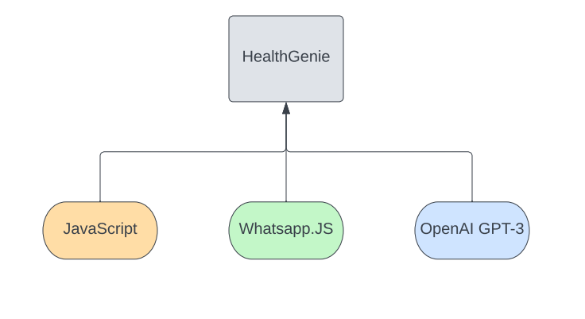

This project would be containing:

1. Logic & working of JavaScript: The API’s would be connected and accessed using the embedded node js tool, which will enable us to run js in windows desktop environment. Using js helps a lot because it supports multitude of libraries and features which are not normally present in other languages like C and C++, python etc.
2. Prompt Engineering: Since the advent of Chat-GPT there is a new field of AI emerging and that is known as prompt engineering. Prompt engineering is the process of fine tuning the AI model and making sure that it gives the desired responses without any noise or unwanted data. This is one of the most crucial processes in making the bot work, as it needs to be very specific about the responses it gives.
3. WhatsApp API: We will be using the whatsapp.js api provided by the official WhatsApp company, which enables us to connect our phone with a desktop computer, we will be redirecting all the responses generated by chat-gpt API to the phone.

In this Section we will do Analysis of Technologies that were used for implementing the project.

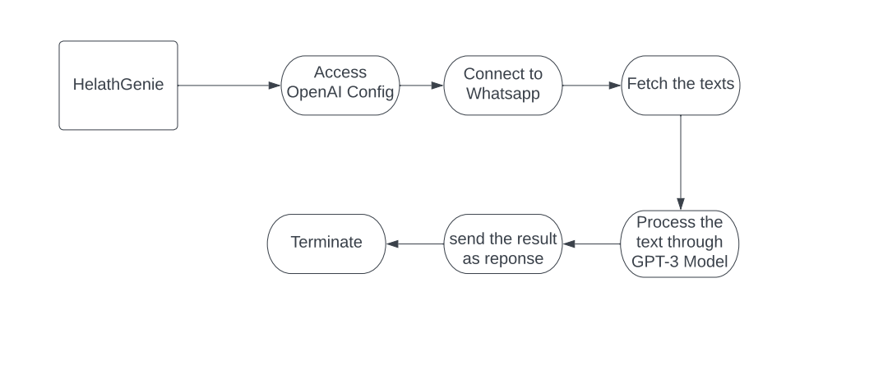

For the implementation of the project, the following methodologies were used-

* Firstly, we accessed the GPT-3 API using the custom configuration as saved in our account, so that the API reference could know that which account was accessing the API.
* We used various parameters while configuring the API, like API key.
* After connecting to open-AI, we configured the WhatsApp API, which works in a similar way to OpenAI API
* We used the QR code generator to convert the WhatsApp key to the QR and show it in terminal, this way, we can easily log in using the WhatsApp scanner.
* After successfully logging in, we have fetched all the texts which were sent to this account by the users.
* WhatsApp automatically looks for unique users and that way it knows which text was sent by whom.
* After fetching the texts, we have configured a base prompt prefix for the openAI model to work on, this helps to process the texts the way we want.
* After the texts are processed through the GPT-3 model using the base prompt prefix, we then use that result as an argument to reply back to the users through WhatsApp.
* And in the end, the final response is sent back to the users.

**3.2 : Technologies used:-**

**3.2.1 JavaScript**



Popular programming language JavaScript is primarily employed for web development. It is a flexible language that may be used in web applications on both the front end (client-side) and back end (server-side). JavaScript enables developers to add interactive and dynamic features to web sites, manage user events, control and change the content of web pages, and exchange data with servers.

JavaScript is widely supported by web browsers and is an essential language for front-end web development. It has expanded its reach beyond the web and can now be used for server-side development, desktop applications, mobile app development (using frameworks like React Native or Ionic), and even IoT (Internet of Things) applications.

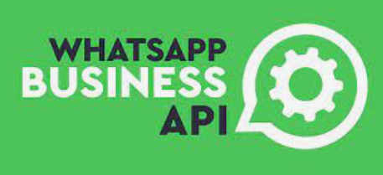**3.2.2 Whatsapp API**

With WhatsApp becoming the most popular direct messaging programme ever, more and more businesses, both offline and online, are understanding how important it is to include this channel into their business.

Being accessible and available on WhatsApp entails giving customers instant communication, which has a big impact on the customer experience.

WhatsApp offers an API (Application Programming Interface) for developers to build integrations and applications that use WhatsApp messaging. The WhatsApp API allows businesses to automate and streamline customer communications, such as sending notifications, conducting surveys, and providing customer support, all through the WhatsApp platform.

With the help of this functionality, which makes use of WhatsApp's APIs, site visitors will be able to start a new chat on the app either directly on the admin's WhatsApp Business page or alternatively on the phone number WhatsApp page.

**3.2.3 Node.js**

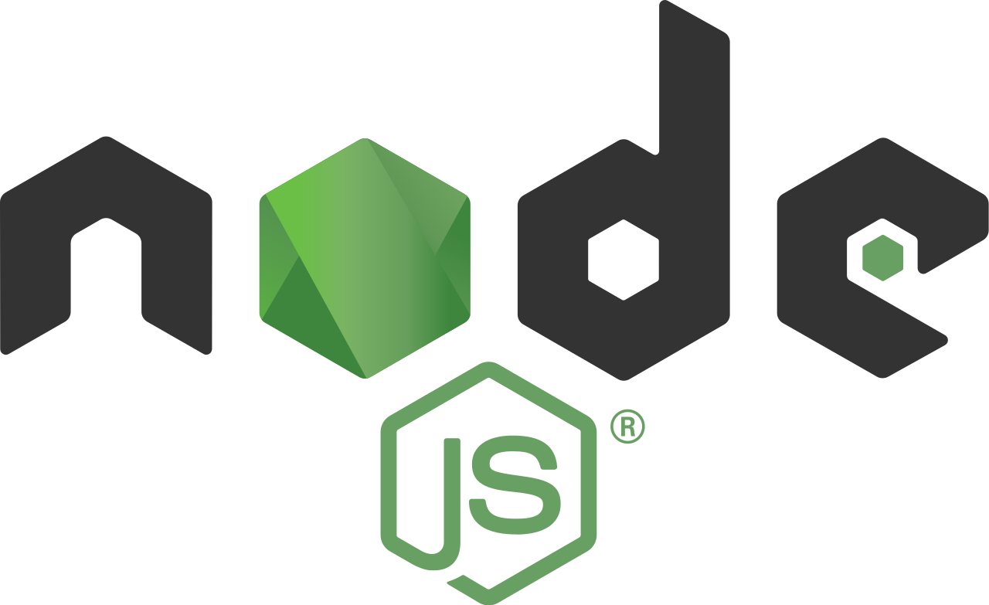

Node.js is an open-source, cross-platform, and server-side JavaScript runtime environment that allows developers to build scalable, high-performance applications. It uses an event-driven, non-blocking I/O model, which makes it efficient and lightweight. Node.js has a large and active community, and it is constantly updated with new features and improvements. Node.js can be used for a wide range of applications, including web servers, command-line tools, and desktop applications.

One of the key benefits of Node.js is its ability to handle large amounts of I/O operations with high concurrency. Node.js uses an event-driven architecture, which means that it can handle multiple requests simultaneously without blocking the event loop. This makes Node.js ideal for building real-time applications such as chat applications and online games. Node.js also offers a wide range of built-in modules that simplify the development process, including modules for file I/O, networking, and cryptography.

Another advantage of Node.js is its ability to integrate with other technologies and platforms. Node.js has a large and active community that has created many useful libraries and modules that can be easily integrated into Node.js applications. Node.js also provides an easy-to-use package manager called npm, which makes it simple to install and manage dependencies. Additionally, Node.js can be used with popular front-end frameworks such as React and Angular, making it a popular choice for building full-stack applications.

Overall, Node.js is a powerful and versatile platform that enables developers to build fast, scalable, and efficient applications. With its event-driven architecture, built-in modules, and easy integration with other technologies, Node.js is a popular choice for building a wide range of applications.

**3.2.4 QR-Code terminal**



QRCode Terminal is an NPM package that allows developers to easily convert data into QR codes and display them in the terminal. This package provides a simple API that developers can use to create QR codes from any string or URL. The generated QR code is then displayed in the terminal, making it easy to share data with other users or devices. This package is useful for developers who need to quickly generate and share QR codes without relying on external services or libraries.

QRCode Terminal uses the qrcode-generator library to generate QR codes from input data. This library supports various QR code types and sizes, making it easy to customize the generated code to meet the needs of different applications. The generated QR code is then displayed in the terminal using the terminal-image library, which

provides an easy-to-use interface for displaying images in the terminal. This package is compatible with all major operating systems, including Windows, macOS, and Linux.

Overall, QRCode Terminal is a useful NPM package for developers who need to generate and share QR codes quickly and easily. With its simple API and support for various QR code types and sizes, this package is suitable for a wide range of applications. Additionally, the ability to display the generated QR code in the terminal makes it easy to share data with other users or devices without the need for external services or libraries.

**3.2.5 OpenAI GPT-3**

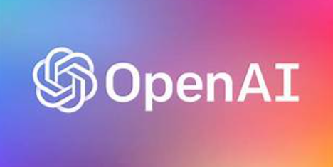

GPT-3, or Generative Pre-trained Transformer 3, is a state-of-the-art natural language processing (NLP) model developed by OpenAI. It is the largest and most powerful language model currently available, with 175 billion parameters, which is over 10 times larger than its predecessor, GPT-2.

GPT-3 is pre-trained on a massive amount of text data from the internet, allowing it to generate high-quality natural language output for a wide range of tasks, such as language translation, text completion, text summarization, and question answering. It can even generate coherent and fluent long-form text, such as essays and articles, that can be difficult to distinguish from text written by humans.

One of the most impressive aspects of GPT-3 is its ability to perform "zero-shot" and "few-shot" learning. This means that it can perform well on tasks it has never been explicitly trained on, and can learn to do so with just a few examples. This makes it a highly versatile and adaptable tool for NLP applications.

**3.3 Constraint Identification**

**3.3.1 Generate multiple design alternates.:-**

When a product is available in different designs where all the designs share the same components, but the arrangement of those components is different in different designs, they are referred as design alternatives .Good designers try to generate as many possible solutions as they can before choosing one that they feel is the best. This creative process of developing ideas is called ideation.

**3.3.2 Methods of ideation include:**

* Examining existing solutions
* Creating and using analogies
* Conducting brainstorming sessions
* Sketching and doodling

**3.4 Selection of best design and implementation plan :-**

In any program or ongoing process, the designing the project is the backbone element. Every project that moves from the development process is unique, with many different scenarios applying to it. However, they all have something in common, the Best Project Design.

Project design is so important that there is no structure for the project development process to stand on and make the project a success in the future. It is such a crucial stage in a project's lifecycle that it identifies key elements and sets the overall tone of the project. To have a successful project, you need to understand the steps involved in project design.

The best project design provides a strategic organization of ideas, materials, and processes to achieve a goal. Project managers use a good design to avoid pitfalls and give parameters to maintain crucial aspects of the project, like the schedule and the budget. Lots of project managers rush into the initialization of the project. Still, an experienced project manager will tell you that the more you invest in your project's front end, the better your results will get at the backend.

**Chapter: 4**

**Results analysis and validation**

* 1. **Important code and website snippets**

**4.1.1 VS Code Index**

It has node modules for running the whole project on backend and and javascript file

For integrating the whole project with OpenAI GPT-3 and using whatsapp interface.

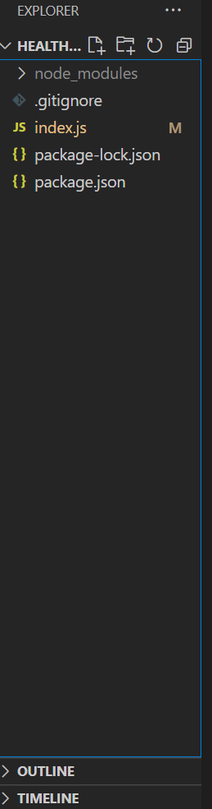

* **JS File**

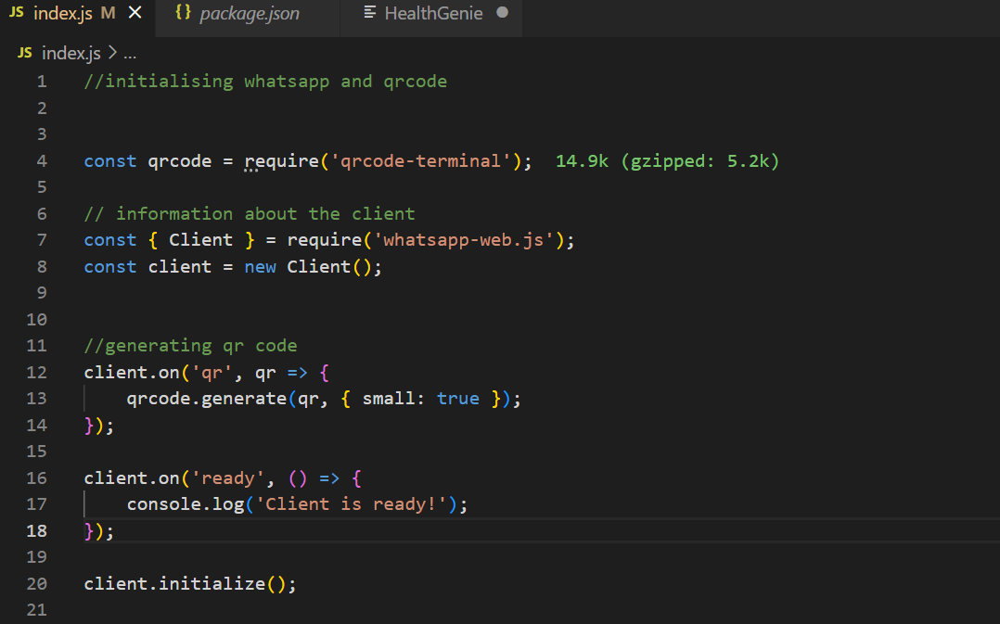

In above code I’ve initialized whatsapp web.js and generated qr code with basic syntax .

Made an object called client and then initialized it as well!

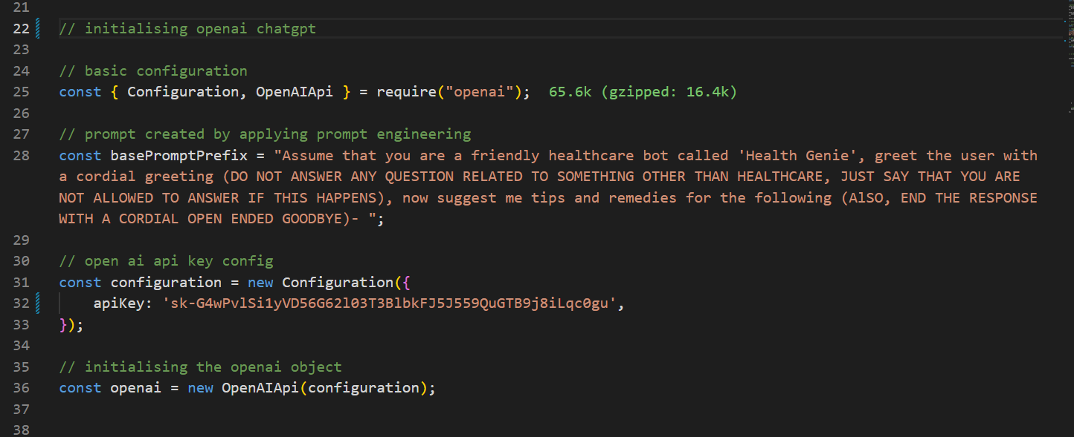

In the next piece of code I’ve worked on integrating chatgpt into my project.

Firstly, I’ve initialized a constant named configuration then passed an argument through it of OpenAIApi.

Then with the help of prompt engineering I’ve generated a base prompt for my model which would help my bot in generating relevant answers. The function basepromptprefix would pass my prompt to openAiAPI.

Then I’ve passed the open ai api key as an argument through my object configuration and initialized an object named openai.

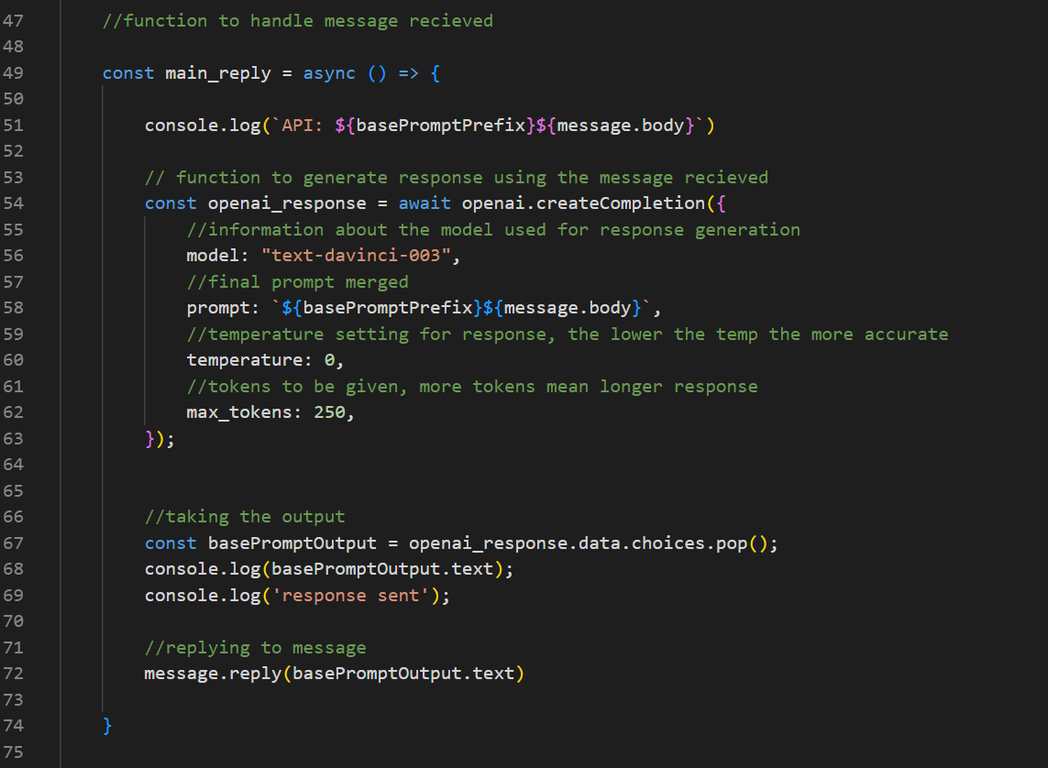

**Now, I’ve generated a function to fetch response from GPT model for the particular input text.**

**Then, I’ve initialized an asynchronous function who would handle the response of the bot to a particular input and the timing of completion of the whole message body.**

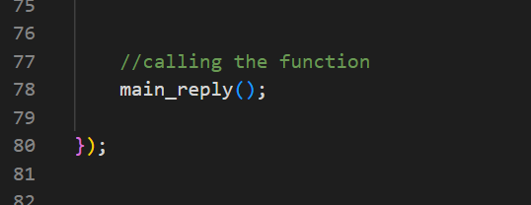

**Lastly I’ll call the function.**

* **Dependencies needed**

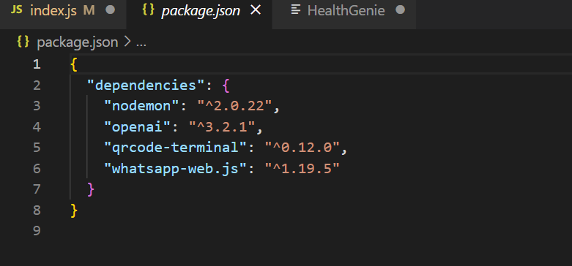

* **ChatBot preview**

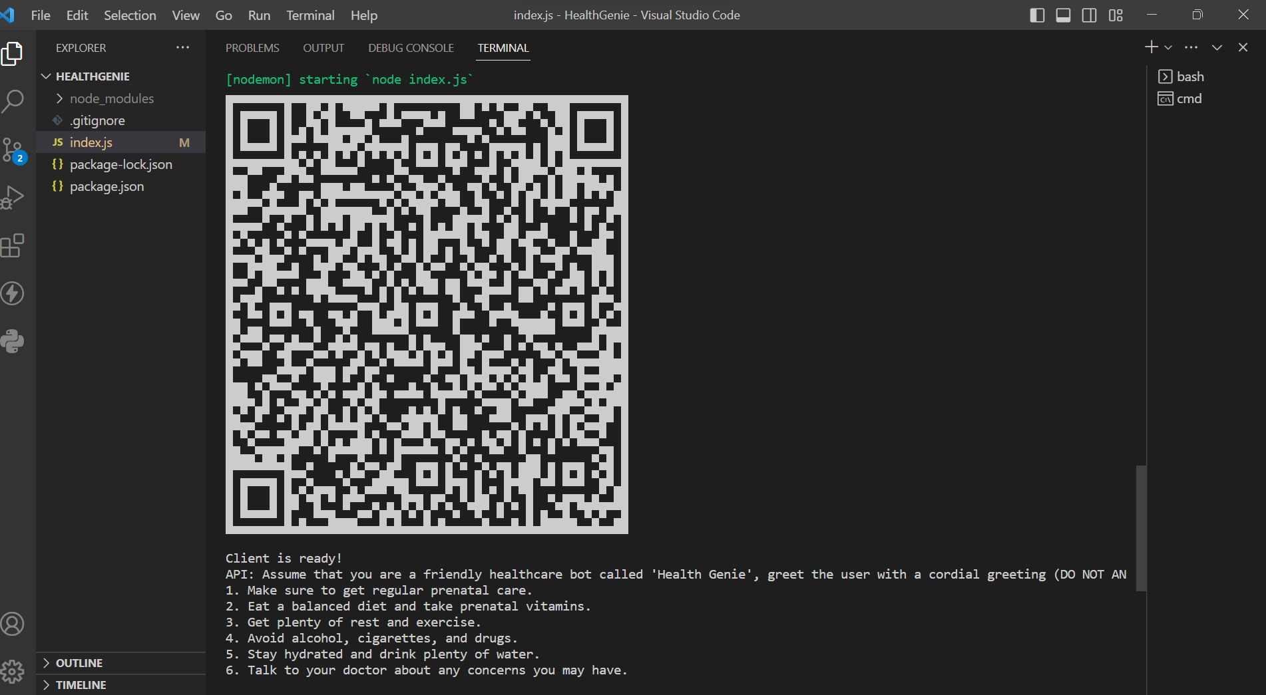

* QR code generated through API

Here, we have generated a QR code inside of our terminal, which will enable us to login whatsapp through scanning the code.

Once we have scanned the code we will logged in and the healthgenie bot will be live.

* **ChatBot preview in whatsapp**

For serious illness it would recommend to seek professional help.

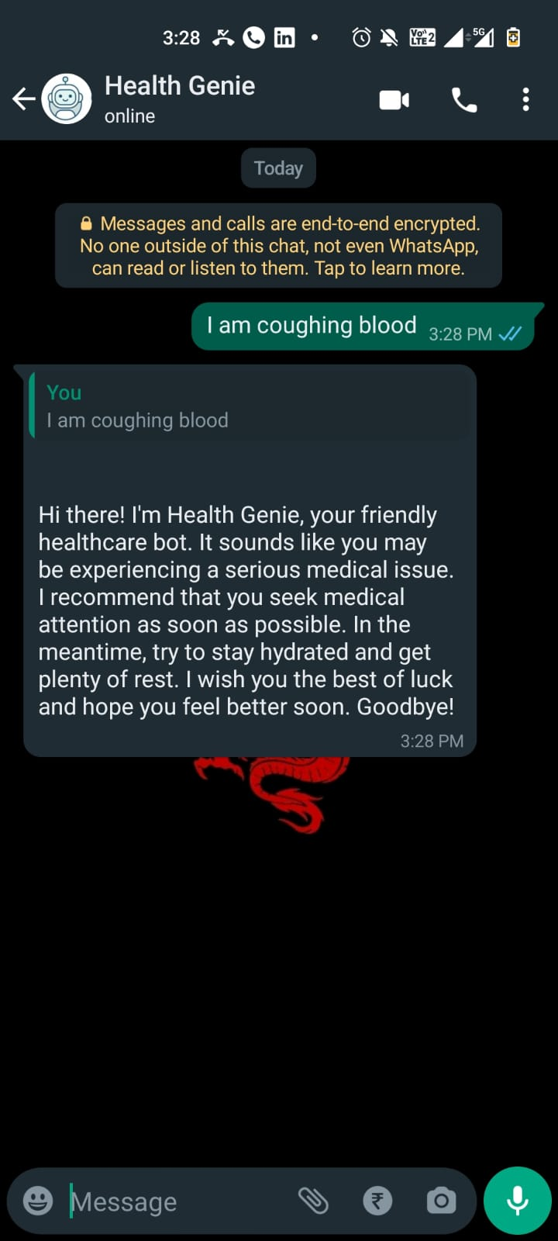

For minor illness it would prescribe medications itself.

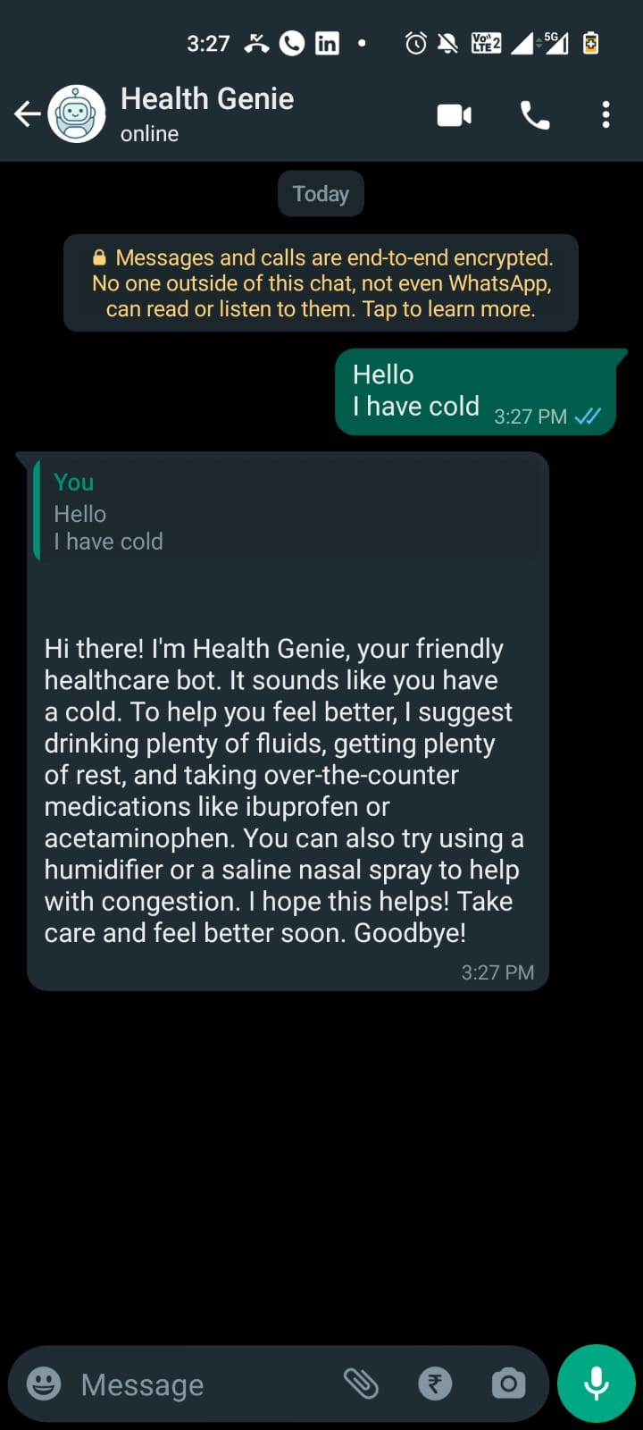

**4.2 TESTING AND IMPLEMENTATION**

The term implementation has different meanings ranging from the conversation of a basic application to a complete replacement of a computer system. The procedures however, are virtually the same. Implementation includes all those activities that take place to convert from old system to new. The new system may be totally new replacing an existing manual or automated system or it may be major modification to an existing system. The method of implementation and time scale to be adopted is found out initially. Proper implementation is essential to provide a reliable system to meet organization requirement.

# **4.2.1 DESCRIPTION OF TEST CASE:-**

1. **ERRORS:-** The term error is used to verified the log in password, balance amount and account searching stage.Due to this the correct user and correct utilization of software responsible.
2. **FAULT:-** It is a condition where the system deny furtherprocess.
3. **FAILURE:-** It is the main ability of a system to perform required function account to specification. The software failure occurs when the behavior of software is different from specified condition.
4. **UNIT TESTING:-**The program unit is usually small enough that the programmer can test it in great details and certainly in greater details than will be possible when the unit integrated into an involving software product.
5. **MODULE TESTING:-**The module relate can be tested without involving other system modules.

**4.2.2 TYPES OF TESTING**

There are five categories of testing which are as follows:-

* Functional test
* 2.Performance test
* Structured test
* User Satisfaction test
* 5 Security Testing
* **Functional Test:-** It involves exercising the code with nominal input value which expected result are known as well as boundary values such as minimum and maximum. The usual software testing activities like test case preparation, test case preview and test case execution is done during this phase.
* **Performance Test:-** It determines the amount of execution time spent in various parts of unit, program response time and device utilization by the program unit.
* **Structured Test:-** It concerned with exercising the internal logic of program and trans versing execution path.
* **User Satisfaction Test:-** It concerned with user comments as well as account holder comments.
* **Security Testing:-** It will ensure that a software does not have any security flows. During test preparation quality, analysis team need to include both negative as well as positive scenario so as to break into the system and report it before any unauthorized individual access.

**4.2.3 : SYSTEM TESTING**

System testing of software or hardware is testing conducted on a complete, integrated system to evaluate the system's compliance with its specified requirements. System testing falls within the scope of black-box testing, and as such, should require no knowledge of the inner design of the code or logic. As a rule, system testing takes, as its input, all of the "integrated" software components that have passed integration testing and also the software system itself integrated with any applicable hardware system(s). The purpose of integration testing is to detect any inconsistencies between the software units that are integrated together (called assemblages) or between any of the assemblages and the hardware. System testing is a more limited type of testing; it seeks to detect defects both within the "inter-assemblages" and also within the system as a whole.

System testing is performed on the entire system in the context of a Functional Requirement Specification(s) (FRS) and/or a System Requirement Specification (SRS). System testing tests not only the design, but also the behavior and even the believed expectations of the customer. It is also intended to test up to and beyond the bounds defined in the software/hardware requirements specification(s).

**4.3 : SOFTWARE VERIFICATION AND VALIDATION**

In software project management, software testing, and software engineering, verification and validation (V&V) is the process of checking that a software system meets specifications and that it fulfills its intended purpose. It may also be referred to as software quality control. It is normally the responsibility of software testers as part of the software development lifecycle. Validation checks that the product design satisfies or fits the intended use (high-level checking), i.e., the software meets the user requirements. This is done through dynamic testing and other forms of review. Verification and validation are not the same thing, although they are often confused. Boehm succinctly expressed the difference between

* Validation : Are we building the right product?
* Verification : Are we building the product right?

According to the Capability Maturity Model (CMMI-SW v1.1)

Software Verification: The process of evaluating software to determine whether the products of a given development phase satisfy the conditions imposed at the start of that phase.

Software Validation: The process of evaluating software during or at the end of the development process to determine whether it satisfies specified requirements.

In other words, software verification is ensuring that the product has been built according to the requirements and design specifications, while software validation ensures that the product meets the user's needs, and that the specifications were correct in the first place. Software verification ensures that "you built it right". Software validation ensures that "you built the right thing". Software validation confirms that the product, as provided, will fulfill its intended use.

From Testing Perspective

* Fault – wrong or missing function in the code.
* Failure – the manifestation of a fault during execution.
* Malfunction – according to its specification the system does not meet its specified functionality

Both verification and validation are related to the concepts of quality and of software quality assurance. By themselves, verification and validation do not guarantee software quality; planning, traceability, configuration management and other aspects of software engineering are required. Within the modeling and simulation (M&S) community, the definitions of verification, validation and accreditation are similar:

**Chapter 5:**

**Conclusion and Future Scope**

**5.1 Conclusion**

My health care chatbot “Health Genie ” has various advantages in today’s world. The goal of "HealthGenie," a healthcare chatbot, is to give an AI assistant that can successfully comprehend and respond to a wide range of patient enquiries, provide individualised health information, and offer assistance on various medical topics. It does this by utilising the ChatGPT platform. ChatGPT's strength rests in its capacity to perceive context, decipher user intent, and produce pertinent and well-thought-out solutions.

ChatGPT can help users prioritise their symptoms, offer initial advice for self-care, or decide whether it is more urgent to seek medical attention. Its extensive knowledge base enables it to provide trustworthy information about medications, treatments, and health issues, enabling consumers to make knowledgeable healthcare decisions.

**5.1 Future Scope**

My chatbot “HealthGenie” is a whatsapp bot which harness the power of chatgpt for answering all the user queries.

The future scope of healthcare chatbots is promising and encompasses various exciting possibilities. Here are some key areas where healthcare chatbots are expected to make significant advancements:

* Integration with Wearable Devices and IoT: Personalised and real-time health monitoring can be provided by healthcare chatbots through the integration of wearable technology and the Internet of Things (IoT).
* Virtual Health Assistants: Chatbots for the healthcare industry have the potential to develop into thorough virtual health assistants. They can act as a one-stop shop for all healthcare requirements, such as appointment setting, medication management, individualised health coaching, and ongoing chronic condition monitoring.
* Can be added to a website: If my chatbot is added to a medical clinic website or hospital website it would benefit the organization greatly.

**REFERENCES**

**WEBSITES**

* <https://help.openai.com/en/articles/6654000-best-practices-for-prompt-engineering-with-openai-api>
* <https://openai.com/blog/openai-api>

**RESEARCH PAPERS**

* **"Chatbots in Health Care: A Scoping Review" by I. Laranjo et al. (2018)**
* **"Implementation and Evaluation of a Chatbot for Personalized Patient Education: Proof-of-Concept Study" by J. Kocaballi et al. (2020)**

**GITHUB LINK FOR THE PROJECT**

**https://github.com/ShrishtyGithub/HealthGenie/blob/main/index.js**